

PROJECT MANAGEMENT | CAD DEPARTMENT

Riser Checklist

**Project Name:**

**Project Manager Name:** David Ketchum

**Project Sponsor:** David Ketchum

**Project Team Member Names:** All CAD Customers

**Date:** 06-21-2017

**Prepared by:** Alex Lundin

# Table of Contents

## Before placing AutoCAD blocks on .dwgs

## Place AutoCAD blocks on .dwgs

## Draw MSTP Splines with BRIDGES sequence

## Fill out SEGMENT and POSITION attribute with AUTOB sequence

## Fill out SEGMENT attribute for Segment Manager

## Create Riser-Layout.dwg with RISERLAYOUT command

## Fix Errors with built in error handlers

## Retrospective Riser

# Riser Checlist

## Before placing AutoCAD blocks on .dwgs

* **Verify that there are no duplicate room names on any of the .dwgs**
  1. Do your best to make sure that there are not any duplicated ROOMIDs on the floor plan
* **Place your own unique Room Identifier next to the customers if necessary**
  1. Under the Extra Blocks Panel -> WS Layouts we have a Room ID block
  2. Make sure to use unique Room Names when placing your own
  3. Something as simple as a extra letter or number will do just fine

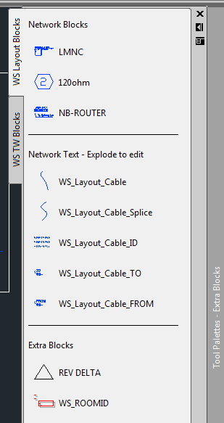

## Placing AutoCAD blocks on .dwgs

* **Complete the block placement for all the layouts**
  1. **Fill out ROOMID for all blocks**
  2. **NOID will move all blocks between layers based on the status of the ROOMID attributes**
     1. Filter is helpful to select blocks at this point
     2. You can re run NOID as many times as necessary after filling out ROOMID’s
     3. NOID2 moves everything off the orange layer regardless of attribute value
  3. **Normal characters and _ only**
     1. The SegMan (Niagara AX) must see an underscore ( _ ) between words or numbers in the device ID.
  4. **Do not use punctuation or other special characters (,/.&*)**
     1. There can be no other symbol, no spaces.
     2. Only an underscore.
  5. **Stay consistent with naming between power and lighting plans**
* **Make sure each networking device listed below has its own unique ROOMID**
  1. In other words: **“One network device per ROOMID”**
  2. GSR has error handlers to redistribute multiple network devices in one room, to multiple rooms, this is for your knowledge.
  3. Example
     1. There are Panels and a Bridge in the same room ELECTRICAL_MULTIPLE_PANELS_101
     2. This is a best practice example so I will abbreviate the room name BP_EMP_101 for
     3. Name the Bridge and all components wiring to the Bridge, BP_EMP_101
     4. Name first panel, BP_EMP_101_P1
     5. Name second panel, BP_EMP_101_P2
     6. So on…
     7. The ROOMID’s shown are arbitrary, you can choose any numbering system as long as each networking device has it’s own unique ROOMID
     8. Please note that if you want to show the room controller, or any other device, wiring to a panel instead of the bridge, then those ROOMIDs have to match.
     9. As an example, the LMSM-104 near the LMCP48 are both labeled BP_EMP_101_P4

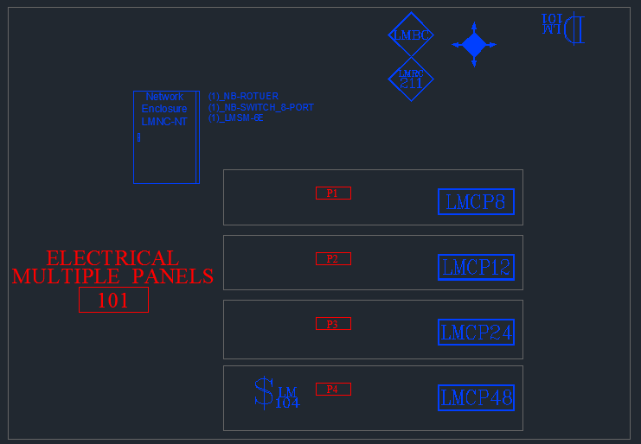

## Draw MSTP Splines with BRIDGES sequence

* **Draw MSTP segments**
  1. Start with BRIDGES and read through the dialog box for more information on how to use the sequence at each step
* **Place exactly one 120 ohm resistor and end of each segment**
* **Use cable identifiers on segments**
* **Use TO and FROM notes for segments between sheet**

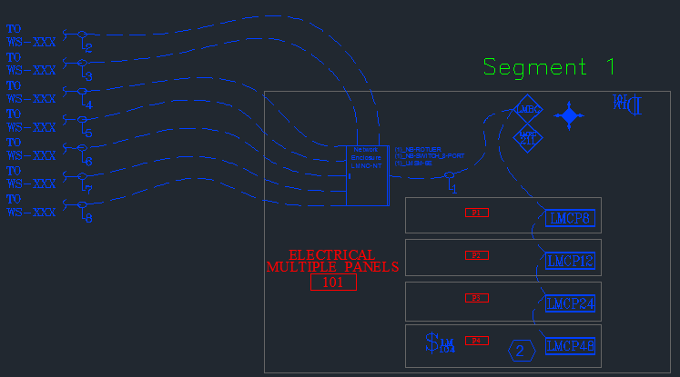

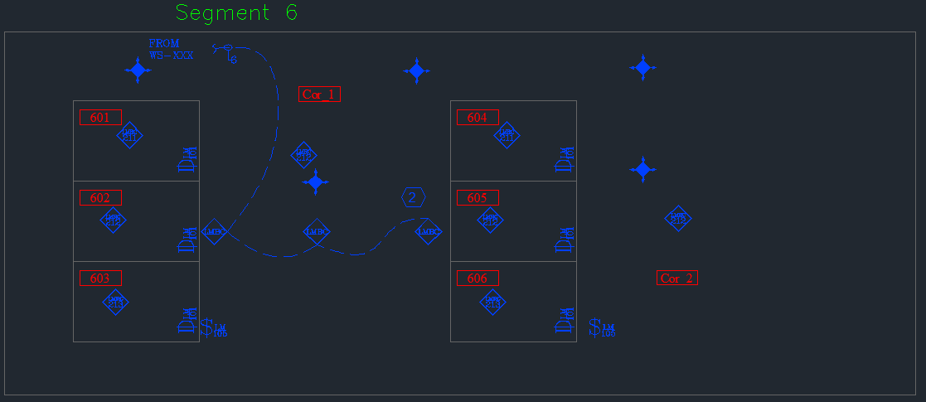

## Fill out SEGMENT and POSITION attribute with AUTOB sequence

* **Use AUTOB to fill out SEGMENT and POSITION attributes for all of the following:**
  + 1. LMBC-300
    2. LMCP-48
    3. LMCP-24
    4. LMCP-12
    5. LMCP-8
    6. Read through the dialog boxes during the sequence in AutoCAD for more information

## Fill out SEGMENT attribute for Segment Managers and routers

* **Manually enter SEGMENT attribute for all of the following:**
  + 1. LMNC
    2. LMSM-3E
    3. LMSM-6E
    4. NB-ROUTER

## Create Riser-Layout.dwg with RISERLAYOUT command

* **Save and close all drawings for the project**
* **Move all layout drawings to a empty folder so they are the only items inside**
* **Open a new WATTSTOPPER.DWT template**
* **Type RISERLAYOUT into the command line**
* **Follow prompts to use command**
* **Open the SR-DLM file and type GSR to generate the Riser**

## Built in error handlers

* **The error handlers will solve the issues below:**
  + **Multiple network devices in one room**
    - Puts first network device in with all DLM equipment
    - Separates remaining network devices into their own separate rooms
    - One network device per room
  + **Network enclosure, segment manager or router missing network attribute**
    - Asks for user input
  + **New product block that is not in template**
    - Code will substitute placeholder block with name of missing block

## Retrospective Riser

* **Follow these steps to create a Riser of the previous version**
* **Move all layout drawings to an empty folder so they are the only items inside**
* **Open a new WATTSTOPPER.DWT template**
* **Type RISERLAYOUT2 into the command line**
* **Follow prompts to use command**
* **Open the SR-DLM-GSR2 and type GSR2 to generate the Riser**